St Barnabas CE First & Middle School

‘Let all that you do be done in love’ – 1 Corinthians Ch.16 vs.14

School Development Plan 2022-3



Context
- DfE Vision - Provide world class education and care that allows every child and young person to reach his or her potential, regardless of background.
- Church of England – Deeply Christian, Serving the Common Good
- Diocese of Worcester Multi Academy Trust - To Love, To learn, To serve

St Barnabas vision for Education
We are an inclusive Church School with a commitment to providing quality education that meets the needs of all. We aim to create successful learners, confident individuals and responsible citizens through our Christian approach of love and cooperation. ‘Let all that you do be done in love’ encourages us to have a lifelong love of learning so we flourish as human beings.

Strategic Plan
In conjunction with DOWMAT the LAB Strategic plan sets out the actions for the Governors to deliver in their key role of setting the strategic direction of the School, and monitoring achievements against the objective of continuous improvement. This is separated into annual implementation plans to show how improvements will be implemented and sustained. Effective school improvement takes three to five years (NFER) and as such the implementation plans follow a cycle of implementation; Explore, Prepare, Deliver, Sustain.
These professional discussions are informed by evidence drawn from the school’s systematic monitoring strategy.Implementation plans are written.

We use carefully chosen questions as a hypothesis which generate professional dialogue / discussion points with staff, SLT, LAB, pupils & advisers

Our evaluation strategy begins with our distinctive Christian vision and all discussions are in the light of this vision

We evaluate that which is of most value to the school / pupils / community we serve

Rigorous quality assurance and impact measures are used to evaluate success for each plan and remaining next steps.



School Development Plan
At anytime St Barnabas school is implementing a range of improvement plans. Some will be in ‘explore’ phase, some ‘delivery’ phase and some will be in ‘sustain’ phase to ensure that the process of implementation is successful this will take more than 1 year at a time. To that end the SDP of St Barnabas is a rolling three year plan. Putting Evidence to Work - A School’s Guide to Implementation | EEF (educationendowmentfoundation.org.uk).
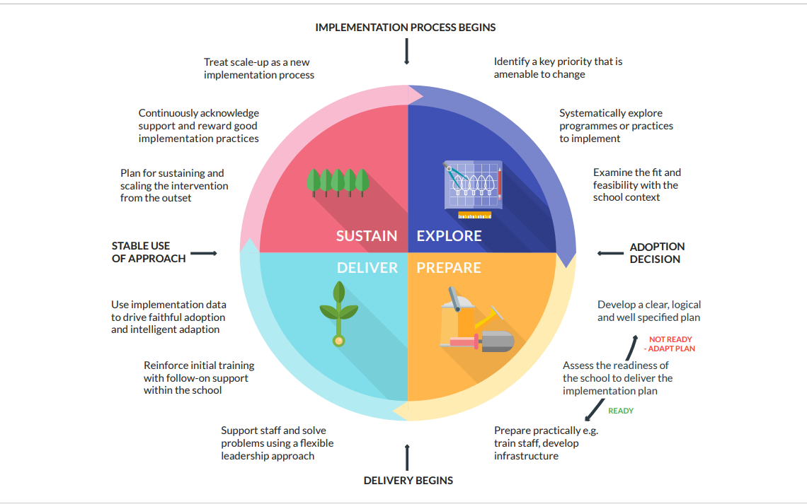

‘One of the characteristics that distinguishes effective and less-effective schools, in addition to what they implement, is how they put those new approaches into practice.’ EEF

2022-5 | 2023-6 | 2024+

Reading – Consistency in teaching and learning of reading skills.

2022-3
Deliver
CPD reading / consistent T&L – Reading Gems implemented

2023-4
Sustain

2024-5
Sustain

Effectively teaching Modelling (I do) as part of the learning process.

2022-3
Deliver
CPD modelling as part of learning process. Lesson obs / lesson self evaluation / coaching

2023-4
Sustain

2024-5
Sustain

Curriculum Leadership – Effective quality assurance to enable leaders to articulate & lead progress in their subject.

2022-3
Deliver
NPQ programmes / coaching from HT / Subject monitoring afternoons.

2023-4
Sustain

2024-5
Sustain

Foundation
Curriculum Assessment

2022-3
Prepare & Explore
Hypothesis? Iis our assessment resulting in improved outcomes – do children know what they need to do to improve?

2023-4
Deliver

2024-5
Sustain

Writing – integration of GPS skills into extended writing across the curriculum.

2022-3
Prepare & Explore
QLA 2022 – cross curricular writing - hypothesis

2023-4
Deliver

2024-5
Sustain

SIAMS / Distinctiveness as A Church School

2022-3
Prepare & Explore – visioning / stakeholder groups / evaluation of current vision and its impact

2023-4
Deliver

2024-5
Sustain

2023-4
Prepare & Explore

2024-5
Deliver

Key Issue:
Teaching and Learning of Reading.
Context / Position Statement:
Explore phase showed inconsistencies in both the planning and teaching of reading across school. Good classroom practice was evident through talking to children, displays, books and planning. Teachers do not feel confident in the teaching of all reading skills. (30.9.22 survey). This reading plan focuses on developing a rigorous plan for reading.
Annotations
Completed/outcomes/evidence Questions/next steps



PROBLEM - WHY?
INTERVENTION
EVIDENCED INFORMED PROCESS
DESCRIPTION – WHAT?
IMPLEMENTATION OUTCOMES – (who, when, how)
IMPLEMENTATION ACTIVITIES - HOW? COST?
FINAL OUTCOMES
There is not a systematic approach to the planning and teaching of reading.

Spiky profile of attainment July 2022
- 76% of all pupils in Y1 passed phonics screening. Gender gap.
- 87% achieved EYFS Reading
- 76% KS1 expected standard, with 33% GDS
- 71% achieved EXS, with 26% DS
- Pupil Premium gap in attainment.
Active ingredient 1

Coverage and progression is clear and shows how Reading National Curriculum skills for each year group are taught.
- Long term map showing high-quality class books / texts that are used in each year – with clear progression, and in line with key themes identified; fantasy / enchanted setting, Diversity & traditional tales.
- Mapped texts show coverage of text types.

Active ingredient 2
Consistent of planning and recording in books
- Agreed planning format
- Agreed how we record
- Inclusion of classics/poetry etc.

Active ingredient 3
Explicitly teach and model the comprehension strategies
KS1 | KS2
Define | Infer
Retrieve | Predict
Sequence | Summarise
Infer | Compare
Predict | Explore
 | Define
 | Relate
 | Retrieve

Teaching sequence: Activating prior knowledge, model, explicit instruction, revisit and apply.

Active ingredient 4
Appropriate intervention for pupils identified as needing additional reading support – diagnostic assessment to inform appropriate intervention.
- Star Reader
- Accelerated Reader
- Rapid Reading
- Phonics intervention
- Precision teaching
Active ingredient 5
Rigorous and robust system of phonics and early reading.

Immediate Term (Autumn 1 term)
Reading lead has finalised LTP ensuring coverage and progression
Reading Lead has mapped high quality texts across school
Readling lead has finalised expectations document inc reading and writing strategy
Fidelity-Reading gems re-introduced to all staff
Reach- teachers and HLTAs can talk confidently about the comprehension strategies
Acceptability – increased subject knowledge of strategies.
Short Term (autumn 2)
Fidelity
Teachers deliver reading gem planning – proforma provided to them.
Staff consistently use Reading gem questions
Rigorous approach to intervention and record keeping for identified pupils
Consistent approach to agreed validated phonics scheme – Rocket phonics
Reading books connect closely to phonics knowledge and scheme
Reach-Pupils talk confidently about each reading comprehension strategy
All appropriate TAs trained in intervention teaching
Medium Term (SPRING )
Fidelity
Staff plan and teach the strands of reading comprehension
Improved consistency in planning and delivery of reading –
Planning provides evidence of the use of comprehension strategies
Consistent, high quality implementation of intervention by TAs
EYFS pupils apply their phonic knowledge in provision
Reach-
100% of staff confident in planning and teaching of phonics in line with validated scheme
All teachers are planning from LTP
All staff model reading strategies and use consistent terminology in their reading lessons.
Acceptability – staff confidence when planning and teaching reading increased (staff survey Jan 2023 & April 2023)
Long Term
Fidelity
The school’s reading curriculum is coherently planned and sequenced towards cumulatively sufficient knowledge and skills.
TAs confident to deliver high quality reading intervention
Reach 100% of staff feel confident in planning and teaching reading.
100% of staff feel confident in planning and teaching phonics with new validated scheme.
Acceptability- staff feel confident and empowered to teach reading comprehension

Short term
Half termly reading records show good progress against book bands.

Book scrutiny of reading books show
- Key reading strategies being taught in line with LTP
- Pupils responding appropriately to Reading Gems questions.

Medium term

Progression in pupil attainment since Autumn term evidenced by progress through book bands, accelerated reader quizzes and teacher assessment of achievement of objectives.

Long term
- Increased attainment in line with national.
From: 2022 data:
Phonics - Year 1- 80%
Reading - Year 2- 76%
KS2 -Reading – 71%

- Pupils identified for intervention show improved outcomes – STAR Reader – reading ages.

- A rigorous and sequential approach to the reading curriculum which develops pupils’ comprehension, fluency, confidence and enjoyment in reading.

Training
Staff CPD
Reading Leader with DOWMAT advisor; weekly Autumn 1
All staff – 31st October- reading implementation
  - Share survey results
  - Share staff forum
  - Share logic model plan
  - Strategies for comprehension (DOWMAT Reading Lead)
  - Reading rope
  - Evidence based practice
  - VIPERS intro
  - share the Vipers planning WAGOLL/time to look

Gap task- teach the planning
Staff meetings - Coaching session – plan next unit with English team
TA training – prevision teaching. Teaching of Reading CPD on each strategy/gap task to try it out
Prediction CPD and Asking Questions
CPD on inference
CPD Retell/paraphrase/summarising
CPD on modelling fluency-
CPD – summary and celebration

Validated phonics training /SLE support
– EYFS and KS1 staff (phonics) with Rocket Phonics
Educational materials
Reading Gems materials
High quality texts including poetry and classics

Coaching & Mentoring
Coaching sessions for supported planning
As practice develops, identify staff champion to support ongoing coaching and provide examples for others
Targeted coaching sessions based on identified need.

Monitoring
English learning walks and lesson observations
Regular item on base meetings
Staff feedback on actions taken and impact
Book and planning scrutiny
Staff voice

Ongoing Reflective Review (LOG) – SDP 1
Priority Development Area:
Date | Chosen actions & activities | How?  What impact measures can you report?  ‘Tell me show me’ | Lessons learned | Next steps  Evidence of outcomes  (develop, change, maintain)
September
October
November
December
January
February
March
April
May
June
July

Key Issue:
Limited use of modelling in the learning process.


Context / Position Statement:
In learning walks & teacher discussion the learning sequence stage of ‘I do’, modelled examples is not consistent across school. All to often teachers gather children’s ideas into supporting any modelled process.
Modelling is a skill which can be transferred across the curriculum. Adults model the process they are going through when they are undertaking a task. Modelling is an instructional strategy where a teacher demonstrates a new concept or approach to learning and students learn through observation. Teachers who model that process will have much fewer questions from children about the process, and can focus on the content of their children’s learning.

FINAL OUTCOMES
IMPLEMENTATION OUTCOMES – (who, when, how)
IMPLEMENTATION ACTIVITIES - HOW? COST?
INTERVENTION
EVIDENCED INFORMED PROCESS
DESCRIPTION – WHAT?
PROBLEM - WHY?

Insufficient time is given to the key stage of modelling within the principles of instruction (Rosenshine & Sherrington).
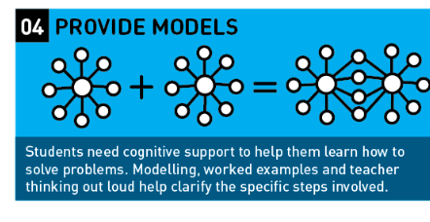
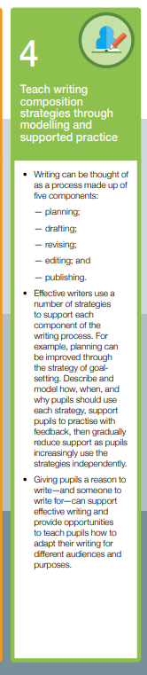
Improving Literacy in Key Stage 2 | EEF (educationendowmentfoundation.org.uk)

Curriculum (skills. Knowledge and understanding)
Planning (objectives, sequence, content and strategies)
Teaching (approaches, time, organisations and experience)
Assessment tools (test, tasks, work)
Assessment Criteria (recording and reporting)

Planning (objectives, sequence, content and strategies)
Teaching (approaches, time, organisations and experience)
Assessment tools (test, tasks, work)
Assessment Criteria (recording and reporting)
on subjects.

Curriculum (skills. Knowledge and understanding)
Planning (objectives, sequence, content and strategies)
Teaching (approaches, time, organisations and experience)
Assessment tools (test, tasks, work)
Assessment Criteria (recording and reporting)

Short Term
100% of teachers use modelling to teach curriculum knowledge / skills / concepts.

Medium Term
Children retain more knowledge, skills and concepts evidenced in achievement of learning objectives.

Long Term
Children achieve expected standard in curriculum subjects.
Children can recall key knowledge and understanding.
Short Term

Fidelity
EEF CPD Mechanisms of professional learning used in the CPD of Modelling.
Lessons show modelling used as part of the teaching process.

Reach
100% of teachers know what modelling is and show a clear understanding of the process of modelling.

Acceptability
Staff surveys show teachers feel increasingly confident in the use of modelling as part of the teaching and learning process.

Medium Term

Fidelity
Tightly focused modelling is used in the teaching and learning process both within lessons, and over time. (Lesson drop ins Spring term)

Reach
Staff coach one another to highlight key strengths in modelling the learning process.

Acceptability
Learning walks and pupil books demonstrate modelling has influenced pupils success in their own work.

Training
- CPD programme – staff meetings on modelling

Coaching & Mentoring
- Use of film / video to record modelling process. Share WAGOLL
- Use of coaching methodology to work through use of modelling as a strategy with teachers.

Monitoring
- Learning Walks – half termly SLT
- Lesson drop ins – modelling is seen.
- Pupil voice – subject monitoring afternoons Jan & May 2023 – children talk about modelling and use the language regularly.

Active ingredient 1
- The learning process is taught for each new concept / knowledge / skill. Sufficient time is given to providing modelled, worked examples. ‘I do’
Active ingredient 2
- Subject knowledge enables teachers to model key features of subject content. E.g. a conclusion in Science, inference in Reading, a balance in PE.
Active ingredient 3
- Professional learning for teachers models ‘EEF Mechanisms for Effective Professional Development’.
- Coaching support is provided for all teachers.
Active Ingredient 4
- Children are familiar with the terminology in the learning process and know the stage of learning process referenced in modelling. Regular reference is made to ‘I do’, ‘We do’, ‘You do’.

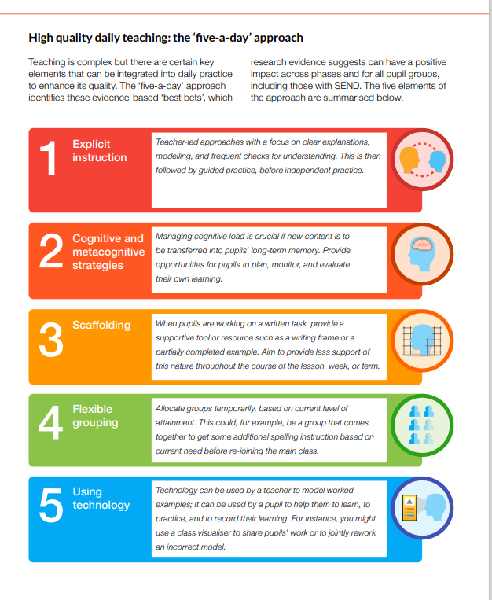



Ongoing Reflective Review (LOG) – SDP 2
Priority Development Area:
Date | Chosen actions & activities | How?  What impact measures can you report?  ‘Tell me show me’ | Lessons learned | Next steps  Evidence of outcomes  (develop, change, maintain)
September
October
November
December
January
February
March
April
May
June
July

Key Issue:

Middle Leadership- holding others to account. Clear articulation of impact.
Context / Position Statement:
Variety of experience of subject leaders. Variation of professional learning in leadership.
New to role leaders – PSHE, DT, Computing.
1 member of SLT completed Maths Mastery & is Maths SLE. 1 member of SLT completed NPQSL.
Not all Subjects leaders are confident in articulating their subject in terms of impact on pupil outcomes.

FINAL OUTCOMES
IMPLEMENTATION OUTCOMES – (who, when, how)
IMPLEMENTATION ACTIVITIES - HOW? COST?
INTERVENTION
EVIDENCED INFORMED PROCESS
DESCRIPTION – WHAT?
PROBLEM - WHY?

Middle leaders are not confident in their leadership skills to develop their subject leader role and hold teachers to account.

Curriculum (skills. Knowledge and understanding)
Planning (objectives, sequence, content and strategies)
Teaching (approaches, time, organisations and experience)
Assessment tools (test, tasks, work)
Assessment Criteria (recording and reporting)

Planning (objectives, sequence, content and strategies)
Teaching (approaches, time, organisations and experience)
Assessment tools (test, tasks, work)
Assessment Criteria (recording and reporting)
on subjects.

Curriculum (skills. Knowledge and understanding)
Planning (objectives, sequence, content and strategies)
Teaching (approaches, time, organisations and experience)
Assessment tools (test, tasks, work)
Assessment Criteria (recording and reporting)

Short Term
100% of subject leaders have action plan with clear areas for development.
Confidence in areas for development following subject monitoring afternoon
Long term plans locked and completed with EYFS key skills.
Long term overviews on the website

Medium Term
Curriculum Quality Assurance triangulates evidence so subject leaders have a clear and accurate overview of their subject area.

100% of Subject Leaders more confident in robust Quality Assurance for their subjects

Long Term
Overall curriculum strengths are articulated and understood by the Governors .

100% of Curriculum subjects are well-led to maximise progress and outcomes for children.
100% of subject leaders can articulate their subject and show impact during a deep dive
Short Term

Fidelity
October -completed curriculum handbook
Sept - Subject monitoring afternoon
October -subject Leaders have action plans
Reach
Long term plans refined with EYFS.
Completed curriculum handbook read by all – shared with TAs
Acceptability
Refined systems for centralisation of key documentation for all subject leaders.

Medium Term

Fidelity
Subject monitoring afternoon shows good coverage of curric areas. Books match time allocated.
Jan - Subject Quality assurance is used to demonstrate the wider curriculum is being delivered effectively.
Reach
CPD takes place and/or coaching for staff who need further input.
Subject leaders use evidence based research to share their expertise and champion their subject
Acceptability
Outcomes from assessment tasks each half term to inform planning

Long Term

Fidelity
The school’s curriculum is coherently planned and sequenced towards cumulatively sufficient knowledge and skills.
Reach
Pupils are able to recall key knowledge
Acceptability
Review of middle leadership as all middle leaders demonstrate the leadership competences.
The website accurately showcases curriculum areas.

- Centralised area for all curriculum documents – branded and consistent
- Each subject leader has a confidential folder for storing monitoring
- All teachers have access to curriculum folders for uploading evidence/resources
- Subject leader roles and responsivities document
- EYFS framework unpicked into preparation for Y1.
- Curriculum handbook
Training
- CPD programme – staff meetings on leadership including training day 5/9/22
- Use subject associations training and webinars to share knowledge and information with teachers.
- Supporting teachers via coaching in key areas of their teaching as required.
Coaching & Mentoring
- Subject leader coaching
- Teachers to be coached by subject leaders as required
- Subject leaders hold teachers to account for the quality of the their subject (planning, delivery and assessment)
Monitoring
- Are the misconceptions from assessment on the feedback documents for subsequent units?
- Subject leader meetings
- Subject leader afternoons for QA (whole school)

Active ingredient 1
Clear procedures and protocols for subject leaders
- Consistent documents
- Subject leader roles and responsibilities
- Curriculum handbook
- Website expectations
Active ingredient 2
Middle leaders can hold teachers to account for effective teaching, learning and assessment in their subject
- WAGOLL – leaders know what good ‘looks’ like in their subject – sequence of learning.
- Regular check ins and coaching support with their subject
Active ingredient 3
A coherent and well-sequenced curriculum in all subject areas
- All subjects show how EYFS curriculum is developed into Y1.
- Clear Learning organisers
- LTP and MTP
- Clear Progression – coverage of National Curriculum is evident
- Enrichment opportunities
Active ingredient 4
Subject leader knowledge
- Subject leaders have subject knowledge to support other teachers
- Following professionals on twitter
- Subject associations
Active ingredient 5
Quality assurance
- Leaders regularly monitor and evaluate developments in their subject.
- Leaders moderate and quality assure to ensure consistency in teaching and learning of their subject across school.

Ongoing Reflective Review (LOG) – SDP 1
Priority Development Area:
Date | Chosen actions & activities | How?  What impact measures can you report?  ‘Tell me show me’ | Lessons learned | Next steps  Evidence of outcomes  (develop, change, maintain)
September
October
November
December
January
February
March
April
May
June
July

