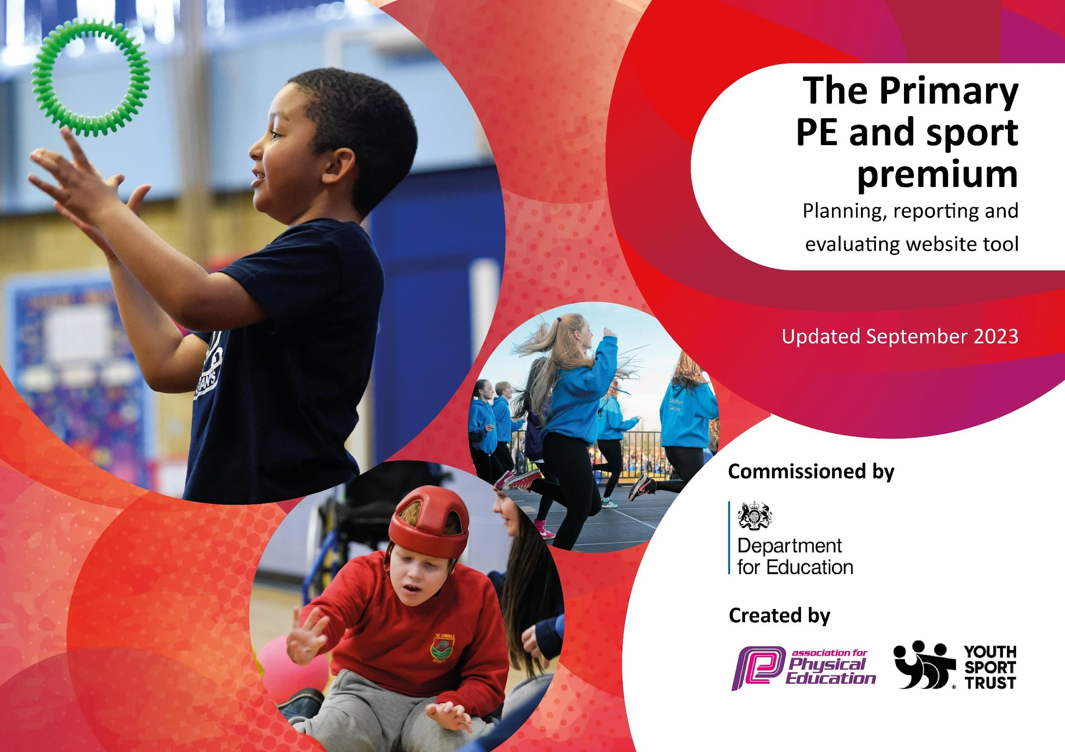

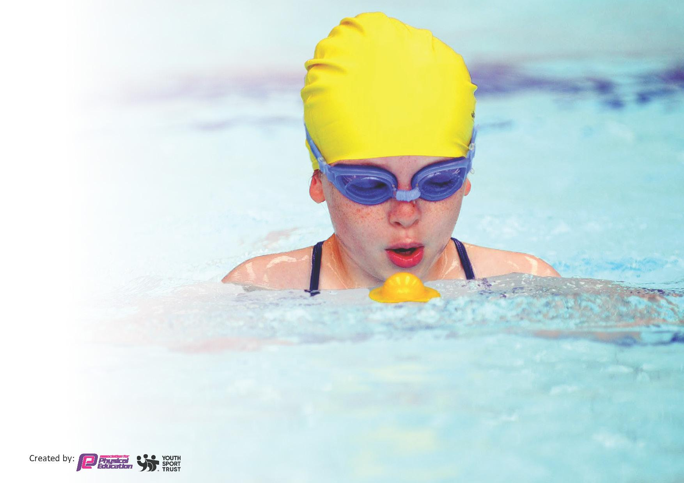
This template can be used for multiple purposes:
by:
- It enables schools to effectively plan their use of the Primary PE and sport premium
- It helps schools to meet the requirements (as set out in guidance) to publish information on their Primary PE and sport premium
- It will be an effective document to support Ofsted inspections enabling schools to evidence progress in Physical Education (PE) and evidence swimming attainment, which forms part of the PE National Curriculum. We would recommend schools consider
the Intent, Implementation and Impact of any spend, as examined within the Education Inspection Framework.

It is important that your grant is used effectively and based on school need.

Schools must use the funding to make additional and sustainable
improvements to the quality of the PE, School Sport and Physical Activity (PESSPA)
they offer. This means that you should use the Primary PE and sport premium to:

- Build capacity and capability within the school to ensure that improvements made now will benefit pupils joining the school in future years
- Develop or add to the PESSPA activities that your school already offers.

The Primary PE and sport premium should not be used to fund capital spend projects; the school’s core budget should fund these. Further detail on capital expenditure can be found in the updated Primary PE and sport premium guidance.

The Primary PE and sport premium guidance, outlines 5 key priorities that funding should be used towards. It is not necessary that spending has to meet all the key priorities, you should select the priorities that you aim to use any funding towards.

Although completing this template is not a requirement for schools, schools are required to publish details of how they spend this funding. Schools must also outline what the impact this funding has had on pupils’ PE and sport participation and attainment and how any spending will be sustainable in the future. All funding must be spent by 31st July 2024.

The Department for Education has worked closely with the Association for Physical Education (afPE) and the Youth Sport Trust (YST) to develop this template and encourages schools to use it. This template is an effective way of meeting the reporting requirements of the Primary PE and sport premium.
Review of last year’s spend and key achievements (2023/4)

We recommend you start by reflecting on the impact of current provision and reviewing your previous spend.

Activity/Action | Impact | Comments
Last year we were very successful with Key Indicator 4: Broader experience of a range of sports and activities offered to all pupils | This developed children’s independence through adventurous activities. Team games provided the opportunity for children to develop teamwork.  Children also had the opportunity to try something new (paddleboarding, kayaking) and enjoyed it which has created a positive learning experience for those children as these are activities that these children wouldn’t have normally chosen to do.

Key priorities and Planning £17390
This planning template will allow schools to accurately plan their spending.

Action – what are you planning to do | Who does this action impact? | Key indicator to meet | Impacts and how sustainability will be achieved? | Cost linked to the action
Bikeability for Year 5 and 7.  Balanceability for REC and Year 1  Scooter bought to assist child with SEN  Introduce lunchtime sport sessions/activities for pupils.  Residentials – Croft Farm and Condover  South Worcs School Sports Association – Subscription Charges  Children to attend sports events and fixtures.  To provide additional opportunities for children to become lifelong swimmers and active adults.  Swimming Charter  Linemarking -  1 x 9v9 & 1 x 5v5 football pitch  Linemarking for sports day  Long jump pit - paint board, rake sand & top up  Sports equipment upkeep  To organize and manage the increased participation in events, organize | All pupils in Year 5 and 7.  Coaches to lead Bikeability  All pupils in REC and Year 1  Coaches to lead activity  Year 5,6 and 7 pupils who have been selected to be sports leaders to lead the activities at lunchtime.  Pupils who are taking part in the lunchtime activities.  Year 5 and 6 attending the residential.  Staff accompanying the pupils. Instructors at both residentials as they will be leading the activities.  Subs are paid in order to  compete in SWSAA events throughout the year  Year 7 boys football team who are attending a tournament at PH. 2 x staff members to accompany.  Mini bus driver  Girls Cricket match.10 girls from years 5&6 traveling to Bredon CC with 2 x Staff accompanying.  Mini bus driver.  Mixed Cricket match.10 children from year 5 traveling to Bredon CC with 2 x Staff accompanying.  Mini bus driver.  Mixed Cricket match.10 children from year 6 traveling to Bredon CC with 2 x Staff accompanying.  Mini bus driver.  4 x pupils from Year 5,6,7 who are attending cross country.  2 x staff as they are accompanying the children.  Mini bus driver  6 x pupils from Year 5/6 who are attending the SEND Bowling competition.  2 x staff to accompany the children.  Mini bus driver  9 x pupils from Year 7 who are taking part in the netball tournament.  2 x staff to accompany.  Mini bus driver  Tennis. 10 children from year 4 traveling to Pershore Tennis Club with 2 x Staff accompanying.  Mini bus driver.  2 x Bell Boating events for year 6. (Practice and Regatta)  4 x staff to accompany.  Coach transport  Skateboarding Event for year 2 at Bromsgrove School.  5 staff accompanying.  Coach transport.  Football event for 5 students from year 6.  2 x staff accompanying.  Taxi transport  Football event for 6 students from years 4 & 5.  2 x staff accompanying.  Taxi transport  Worcs Girls Can event at TDMS Evesham. 4 students from year 7 attending with a member of staff.  Taxi transport.  Swimming coach  Mini bus driver  Children who are identified | Key indicator 2: Increase engagement for all pupils in regular physical activity and sport.  Key indicator 2: Increase engagement for all pupils in regular physical activity and sports.  Key indicator 2: Increase engagement for all pupils in regular physical activity and sports.  Key indicator 2: Increase engagement for all pupils in regular physical activity and sports.  Key indicator 4: Broader experience of a range of sports and activities offered to all pupils.  Key indicator 4: Broader experience of a range of sports and activities offered to all pupils  &  Key indicator 5: Increase participation in competitive sport.  Key indicator 3:The profile of PE and sport is raised across the school as a tool for whole school improvement  &  Key indicator 4: Broader experience of a range of sports and activities offered to all pupils  &  Key indicator 5: Increase participation in competitive sport.  Key indicator 3:The profile of PE and sport is raised across the school as a tool for whole school improvement  &  Key indicator 4: Broader experience of a range of sports and activities offered to all pupils  &  Key indicator 5: Increase participation in competitive sport.  Key indicator 3:The profile of PE and sport is raised across the school as a tool for whole school improvement  &  Key indicator 4: Broader experience of a range of sports and activities offered to all pupils  &  Key indicator 5: Increase participation in competitive sport.  Key indicator 2: Increase engagement for all pupils in regular physical activity and sports  &  Key indicator 4: Broader experience of a range of sports and activities offered to all pupils  Key indicator 1: Increased confidence, knowledge and skills of all staff in teaching PE and sport  Key indicator 3:The profile of PE and sport is raised across the school as a tool for whole school improvement  &  Key indicator 5: Increase participation in competitive sport.  Key indicator 3:The profile of PE and sport is raised across the school as a tool for whole school improvement  Key indicator 5: Increase participation in competitive sport.  Key indicator 3:The profile of PE and sport is raised across the school as a tool for whole school improvement | 60 children passed from Y5 and Y7. Re-planned for next year. Increased number of children safer cycling on roads.  41 children took part. Increased number of children with improved road sense.  6 children took part.  Huff and Puff boxes regularly used at lunchtime to engage children in physical activity. Positive feedback from children and staff about engagement.  30 Chilldren went to Croft Farm.  28 Children went to Condover Hall  100% of children who attended broadened their experience of outdoor and adventurous activities. Children reported interest and enjoyment. Staff reported resilience and positive attitudes.  48% of school had the attended a SWSAA event in 2023/4.  94 children took part in inter school experiences. Information shared with parents and the profile raised through regular newsletters.  see above  Top Up swimming enabled additional 15 children to engage in swimming as well as 19 children from Y4.  Swimming is a life skill – top up swimming lessons ensure children are equipped with the skills to remain safe in water.  All sporting activities were completed on appropriate marking and enabled children to maintain accuracy and fidelity to the sport.  74% of children achieved the objectives for their year group  Increased profile as a school across the borough. Parents and children are aware of the SWSS. Increased pride from school family. | £275  £82  Scooter: £97.50  1 x MDS £2915.41  £1500 (Y5 trip  £50 per student)  £1400 (Y6 trip  £50 per student)  SWSSA subscription  £200  £2245.08 minibus insurance  Minibus maintenance: £1541.32  Staffing allocation of costs to attend out of hours / drivers / additional adults: £1141  Bellboating Coach 1: £369  Bellboating Coach 2: £369  Royal Motorways Coach - Skateboarding:  £380  Backminster Middle School  £80  Taxi: £90  Swimming Taxi:£1200  (30 x £40)  Pool Hire: £1178.25  £36 (Credit card payment)  Smart Cut Line marking: £192  Smart Cut Line marking: £415.80  £96  Sportsafe survey: £236.40  Sportsafe repairs: £280.22  Training tennis balls: £53.99  Tennis Racket repair: £15.98  Office hours and supply non contact for PE lead. £1000  TOTAL : £17390.

Swimming Data
Meeting National Curriculum requirements for swimming and water safety.
Priority should always be given to ensuring that pupils can perform safe self-rescue even if they do not fully meet the first two requirements of the National Curriculum programme of study

Question | Stats: | Further context  Relative to local challenges
What percentage of your current Year 6 cohort can swim competently, confidently and proficiently over a distance of at least 25 metres? | 85%
What percentage of your current Year 6 cohort can use a range of strokes effectively [for example, front crawl, backstroke, and breaststroke]? | 75%

What percentage of your current Year 6 cohort are able to perform safe self-rescue in different water-based situations? | 90%
If your schools swimming data is below national expectation, you can choose to use the Primary PE and sport premium to provide additional top-up sessions for those pupils that did not meet National Curriculum  requirements after the completion of core lessons. Have you done this? | Yes
Have you provided CPD to improve the knowledge and confidence of staff to be able to teach swimming and water safety? | Yes
Signed off by:

Head Teacher: | Elizabeth Whehtam
Subject Leader or the individual responsible for the Primary PE and sport premium: | Elizabeth Whetham -June 2024  Eleanor Holman – Sept 23-June 2024
Governor: | (Name and Role)
Date: | 18/8/24

