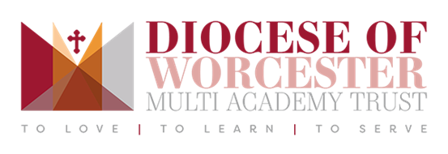

Public Consultation – 11th October to 26th November 2021

Proposed Change of Age Range of St Barnabas CofE First and Middle School

Introduction

This document helps to explain the background to the proposals and the steps of this process, including:

- the background to proposals;
- who can propose and decide on changes;
- what is being proposed;
- why it is being proposed;
- the impact of the proposals;
- how and when the proposals if agreed would be implemented;
- who is being consulted;
- how to submit a consultation response; and
- what happens at the end of the consultation period.

If you require any additional information not included in this document to enable you to make a response, please contact PershoreReview@worcschildrenfirst.org.uk or the school:

Address | St. Barnabas CE First and Middle School, Stonebow Road,  Drakes Broughton,  Pershore,  Worcestershire  WR10 2AW
Email | office@st-barnabasfirstmiddle.worcs.sch.uk
Phone number | 01905 840366

Have your say…

It is very important that all those involved or have an interest have a say, we welcome your views.

An online survey can be accessed from the school website or Worcestershire County Council Pershore Review webpage. If you are unable to access the online response form, please email the school office.

Paper responses must be submitted to the school office.

The seven-week consultation period commences on Monday 11th October and closes at noon on Friday 26th November 2021. It is very important that all those wishing to respond to these proposals do so within this timeframe.

We are holding a consultation event to allow our stakeholders to learn more about our proposals and give the opportunity to provide feedback. A summary of events can be found in the table below:

Date & Time | Location & address | Delivery
Thursday 21st October  3.30pm | St. Barnabas CE First and Middle School, Stonebow Road,  Drakes Broughton,  Pershore,  Worcestershire  WR10 2AW | Face-to-face
Thursday 21st October  1pm | Topic: Pershore Area Age Range Consultation  Time: Oct 21, 2021 13:00 London  Join Zoom Meeting  Meeting ID: 831 6368 5420  Passcode: 648005 | Virtual (via Zoom)

Yours sincerely,

 | 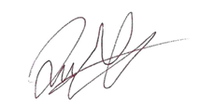 | 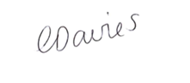
Stephen Booth  Headteacher | Quintin Spears  Chair of Local Academy Board | Claire Davies  DoWMAT CEO

Responses required by noon on Friday 26th November 2021

School Details

Name and Address: | St. Barnabas CE First and Middle School,  Stonebow Road,  Drakes Broughton,  Pershore,  Worcestershire  WR10 2AW
Status: | Academy
Ofsted Rating / Date: | Requires Improvement January 2020
Current age range: | 4 to 12 | Proposed age range: | 3 to 11
Point(s) of Entry: | Reception & Year 5 | Proposed point(s) of entry: | Reception
Total pupil capacity as of 1st September 2021: | 390 | Proposed total pupil capacity: | 315 plus Nursery
Published admission number (PAN) as of 1st September 2021: | 30  (Yrs R,1,2,3,4)  80 (Yrs 5,6,7) | Proposed PAN: | 45  (Yrs R-6)
Currently pupils’ transition to: | Middle School at Year 5 | Proposed for pupils to transition to: | High School at Year 7

Background information

The Pershore Education Planning Area is made up of 16 Schools serving the town of Pershore and surrounding rural area. From September 2019 several schools had proposals agreed to change age ranges to create an option for a two-tier (Primary and Secondary school) system of education for families. A total of 6 schools in the Pershore area currently operate as Primary and Secondary schools.

St Barnabas CE First & Middle School currently enjoys the unique status of being the only combined First & Middle School in the UK. The school provides education for children aged from four in our Reception class, to twelve-year old students in Year 7.
We value our Voluntary Controlled status and our close links with the local church as well as being part of the Diocese of Worcester Multi Academy Trust (DOWMAT). We also work closely with the Worcestershire Diocesan Board of Education Team.
Members of the Local Academy Board, teachers, support staff, parents and friends work together to ensure that the wellbeing of the children is at the heart of all that we do. We ensure that the lively, stimulating and caring environment within the school enables the children to progress to achieve their academic potential and to develop as balanced, well-adjusted, thoughtful and polite young people.
We see education as a partnership between children and adults and look to work closely with our families to empower our pupils to develop a lifelong interest in learning.
St. Barnabas CE First and Middle School joined the Diocese of Worcester Multi Academy Trust in March 2017 and, as a result, benefits from a dynamic collaborative network of 15 academies and the extensive school improvement support the Trust offers.

What is proposed

It is proposed to alter the age range of St Barnabas CofE First and Middle School from 4-12 to 3-11. This would change the school from a first & middle school to a primary school.

Children would remain at the school for Years 5 and 6. Children in Year 6 would then transition to a Secondary School for Year 7 onwards.

Historic and Forecast number on roll at St Barnabas First and Middle School:
 | Reception | Year 1 | Year 2 | Year 3 | Year 4 |  | Year 5 | Year 6 | Year 7 | Total
Oct 2020 | 18 | 23 | 24 | 26 | 21 |  | 34 | 49 | 50 | 245
Oct 2021 | 24 | 23 | 28 | 29 | 31 |  | 33 | 39 | 53 | 260
Oct 2022 | 36 | 26 | 25 | 30 | 31 |  | 35 | 35 | 40 | 258
Oct 2023 | 40 | 38 | 28 | 27 | 32 |  | 33 | 37 |  | 235
Oct 2024 | 33 | 40 | 38 | 28 | 27 |  | 32 | 33 |  | 231
Based on 5-year average transfer rates and anticipated stay on rates to year 5 based on similar school conversions. Includes children from expected new housing developments.

The school is currently built to support 390 pupils, with 211 pupils currently on roll. The primary school could accommodate a total of 315 pupils.

Incorporate 3 year old nursery children

It is proposed to lower the age range of St Barnabas CE First & Middle School from 4 years to 3 years to incorporate provision for three-year-olds into the offer of the school. In order to do so the age range of the school must be lowered.

Changing the age range of the school and operating three-year-old provision as part of the maintained school will have a number of benefits:

Children attending the three-year old provision can be integrated fully into the school community. Parents and carers will benefit from the opportunity to pay for services using online methods. Registration of all children will be consistent, as will tracking of attendance and attainment.

The school offer a fully inclusive environment, linking with Health and Social care professionals, which allows the school to identify early concerns and address barriers which are preventing swift progress whilst developing excellent relationships with families. The introduction of children into this journey from two will further this programme and support the school to continue to improve outcomes for children and support vulnerable families.

In addition, being able to ensure the staff: pupil ratios reflect children’s needs rather than the provision’s legal requirements will enable all children to transfer to their Reception Class with a greater understanding of needs, interest, strengths and difficulties which will allow them to flourish.

Why is it being proposed?

Changes to schools in the Pershore education planning area over several years has led to uncertainty and sustainability concerns across the education planning area. At present, one school exists outside of the Pershore tier structure in the two-tier Catholic pyramid; six schools have changed or have approved changes to two-tier; and two further schools have already consulted on change of age range proposals.

The creation of additional places in years 5, 6 and 7 as a result of the approved changes has resulted in an unsustainable level of surplus/excess places in these year groups. By 2023 we anticipate that two of the middle schools in the area will be operating at around 50% capacity, which creates significant difficulty to provide key stage 3 (Year 7, ages 11 to 12) curriculum in particular.

Over the last two years when a choice has been available, we have seen parents in the area choosing a Primary and Secondary (two-tier system) education in their school admissions applications, with an increasing percentage choosing to remain at already converted primary schools and a number choosing to transfer from first to primary schools during Key Stage 1 and 2.

This creates a risk to ensuring clear and high-quality education journeys for pupils.

St. Barnabas has seen the impact of this over recent years, especially since the conversion of one of its main feeder first school to a primary in 2020. Previously the school catered for three classes in each of its year groups 5, 6, and 7. Moving forward the school is looking to take in one class of up to 30 pupils in Years 5 and 6, moving to a 45 intake as housing developments in the area result in more children needing a school place.

St Barnabas CE First and Middle School Pre-School has growing numbers of children over the last several years. The following table details the number of pre-school children over the last 4 years:

Academic Year | Funded 3 & 4 year olds on roll
2018/19 | 31
2019/20 | 24
2020/21 | 22

Parents and Carers also appreciated the approach to create developmentally appropriate provision which reflects the strengths and needs of all children in the nursery school without division according to age.

Who can propose and decide the changes?

All schools in the Pershore pyramid have agreed to consult on the proposal for an area-wide transition to a two-tier system of education, however, there is no single decision-making body that can legally agree such a change for all schools. The Local Authority in their capacity as Education Authority have agreed to coordinate this consultation but are not able to solely determine these changes. For details on the types of changes and the decision-making powers for each school, please see below:

For Academy Schools:

Expansion & Change of Age Range
Academy schools that are rated ‘good’ or ‘outstanding’ at their last inspection, are in good financial health, and are proposing a change that is not contentious or subject to objections from the LA, may propose to expand their physical capacity and / or change the age range of their school by up to two years (including adding nursery provision but excluding adding or removing a sixth form) by following a fast-track process. Academy Trusts proposing to change the age range of their schools by three years or more, those which want to add or remove a sixth form, make any age range change which is contentious, or which will set a precedent for schools in their local area, must submit a full business case.
The Regional Schools Commissioner (RSC) is the sole decision maker for proposals for Academy schools. The RSC will consider a range of factors and make a balanced judgement when deciding whether to approve or reject a proposal. The RSC may also defer the approval pending further evidence. Where proposed changes are particularly controversial and could attract adverse public or press attention; the RSC may choose to escalate such proposed changes to the Secretary of State for a decision.

Changes to Admissions Policies

Published Admissions Number (PAN) where an enlargement of premises has not taken place.
Changes to admissions policies include alterations to the Published Admissions Number (PAN) of schools, as well as changes to feeder school links and other changes affected admission to a school. Admission authorities must set a PAN for each ‘relevant age group’ when determining their admission arrangements. If an admission authority of a mainstream school wishes to increase or decrease PAN, without increasing the overall capacity of the buildings, this would be classed as an admissions change, not a prescribed alteration. The statutory process described in this guidance would not need to be followed (please see the School Admissions Code for further details of the processes admission authorities must follow).

Admission Arrangements
An age range change may, in certain circumstances require changes to admission arrangements in order to implement the change. In such cases, schools must follow the admissions variation process.
An amalgamation is also likely to require an in-year variation of the school’s admission arrangements. A request for an alteration to admission arrangements, in line with process, can be made at the same time as the school makes an application for a significant change.
Consultation on school admission arrangements

The Impact of the Proposal

Worcestershire County Council is committed to supporting schools, these proposals are expected to provide the following benefits to Pershore schools and local families:

- every child has a clear and transparent education journey;
- schools are supported to deliver good education outcomes in a stable and known education system; and
- schools are able to deliver a full curriculum and remain sustainable and financially viable.

Quality of provision and breadth of curriculum

All teachers at St. Barnabas CE Middle School are qualified to teach across the whole primary age range and have previous experience of working in schools offering full primary provision.

The staff have a range of expertise which covers the full primary curriculum. In addition, the school works closely within the DoWMAT to share best practice and ensure teaching provision and the quality of education is up to date and of high quality.

The proposed changes will have no detrimental impact on the quality of education for any of its pupils.

In addition, despite the changes, the new St. Barnabas CE Primary School will benefit from all the specialist facilities currently on offer to Year 7 pupils; especially with regard to PE, Science, and IT.

Accommodation Required

No additional accommodation is required to support this change.

Over the past four years, St. Barnabas has benefitted from over £500,000 from the Conditions Improvement Fund (CIF), designed to support improvements to academy buildings, plus Section 106 funding. This has enabled the Trust to make substantial renovations to the building and to provide a new modern classroom base to replace old mobiles. The buildings are bright and spacious and there is ample capacity to support the school’s intention to become a one and a half intake primary school, with a PAN of 45.

School Transport

Changes to schools can have an impact on transport for individual pupils. However, the current Transport policy is designed to support schools and pupils in a settled education planning area, therefore, the policy is currently out of line for all options during transition phase but would be suitable once a single pathway is in place.

To manage this, for those pupils attending a school at the time of the change ordinarily eligible for transport support, special transport arrangements may be put in place to assist during the transition phase. Once the changes have been implemented any new pupils joining the school will be subject to the normal application of the transport policy.

School staff

Implications for school staff would include reductions in some schools and the need for more staff in other schools. For the two academy Middle schools, this has already resulted in a number of redundancies for existing staff and the costs associated with this. Further redundancies will be expected as part of the re-organisation. The Education and Skills Funding Agency (ESFA) have been notified of this concern and are working with the Multi Academy Trust. Individual schools and Trusts will work as far as possible to support staff as part of the proposed changes.

Vulnerable pupils

It is envisaged that the change to a single tier system will make education transitions clearer and more straightforward and support, in particular, pupils from vulnerable backgrounds.

There is a strong Gypsy, Roma, Traveller community within the wider Pershore area and a specific assessment will be undertaken to ensure pupils from this community are supported during this change.

Financial – Capital

These proposals will have capital and revenue implications for a number of different education providers in this area. Detailed feasibilities have begun at required schools to understand full capital and revenue costs and accommodation implications.

The expectation will be that the DfE will support funding for Academy Trusts in either revenue or capital funding requirements.

Financial – Revenue

Revenue implications for schools are yet to be fully determined – whilst middle schools may be at increased risk from financial deficits during the change period as pupil numbers decrease, Primary and Secondary schools will have an increase in numbers and pupil-led funding, however it is likely to take time before revenue costs for primary schools are directly aligned with pupils in the classroom. The revenue implications will need to be reviewed and carefully managed on a school-by-school basis.

Funding considerations for decision makers

When determining these proposals, the decision-maker in each case should be satisfied that any necessary funding required to implement the proposal will be available and that all relevant local parties (e.g., trustees of the school, diocese or relevant diocesan board) have given their agreement. A proposal cannot be approved conditionally upon funding being made available.

Other education areas

Some schools in Pershore education planning area attract pupils from outside of the Pershore area, for example from Evesham, Droitwich and Worcester. These proposals could impact the number of pupils able to transition into the Pershore schools because of the proposed feeder school changes and the proposed changes of age range will alter the intake points.

Evesham operates mostly a three-tier education system (First, Middle and High schools) with intake points that differ to those of Pershore and are at Year 6 (Middle) and Year 9 (High). There are three Primary schools in the Evesham area. 2021 is the only year with data for Year 7 which showed 2 children moving from Evesham to Pershore. Pupils’ resident of Birlingham, Eckington can currently transfer to a Middle School in Pershore or stay in Evesham schools. If Middle Schools in Pershore close, there would no longer be a normal phase transfer point for Eckington pupils. Families could apply for places into an existing year group. In September 2021 no children leaving Year 5 in Eckington transferred to a Pershore Middle school.

Droitwich operates mostly a three-tier education system which is in line with the Pershore transition points (First, Middle and High schools) with intake points at Year 5 (Middle) and Year 8 (High). There are four Primary schools in the Droitwich area. For Year 5, the 5-year average shows 10 pupils moving from Droitwich to Pershore. In September 2021 there were no Year 7 pupils moving from Droitwich to Pershore. The proposed change of age ranges in Pershore would remove the same year group transition / intake points as Droitwich. Therefore, families in Droitwich wanting to move to Pershore High for Secondary school provision would need to apply at Year 7 or request to transfer for year 8 if places are available.

Worcester operates a two-tier education system (Primary and Secondary schools) with intake points in Year 7 (Secondary). This would align with the proposed changes in the Pershore area.

How and when if approved would the proposals be implemented?

As part of this consultation, stakeholders are being asked to consider, if approved, when they would like the changes to take effect from. We have created a Pershore Education Journey Tracker for pupils, parents and professionals to see in detail how the three options below would change the journey for pupils in the Pershore education planning area should the proposals be approved, and the year groups available at each school.

There are three options to manage the proposed changes:

Option 1: Transition in line with natural progression, coordinated age range changes and coordinated accommodation changes. All changes made by September 2024.
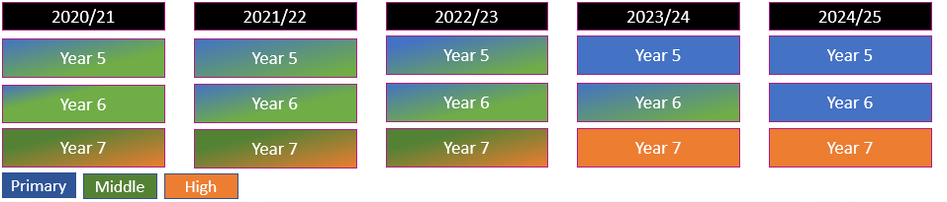

School changes
- Change of age range at First schools in 2022 and 2023. All First schools to convert to Primary by September 2023
- Removal of Year 5 intake and change of age to remove year 7 for Middle schools from September 2023
- Increase of PAN and change of feeder links at Pershore High for 2023 to admit all pupils in year 7 in pyramid.

Impact
- Final year 5 intake in September 2022 at Abbey Park Middle and St Nicholas Middle to be the only year group on roll in Middle schools in 2023/2024 (year 6).
- Students applying for Middle school places (1st September 2021 to 15th January 2022) for September 2022 will not know at point of application that Middle schools will not be delivering year 7 places.

Option 2: Year groups 5 & 6 closed in Middle schools early, impacting pupils’ journeys and greater impact for families. Children would need to change school after year 5 for one year. All changes made by September 2023.
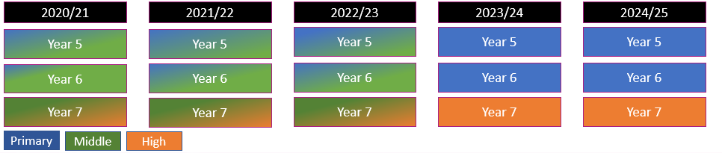

School changes
- Most First schools to convert in ’22. All schools to convert to Primary by September 2023
- Closure of Abbey Middle School and St Nicholas CE Middle from September 2023 and applications made by pupils in year 5 to transfer back to a Primary for Year 6. Change of age range of St Barnabas CE First and Middle for September 2023
- Increase of PAN and change of feeder links at Pershore High for 2023 to admit all pupils in year 7 in pyramid.

Impact

- Middle school September 2022 year 5 intake would be required to make three school applications in three years (and three transport applications where applicable)
- Rapid change for Abbey Park First and Pinvin C.E. First which will jump from R-Y4 to R-Y6 on roll in single year.

Option 3: Emergency variation to admissions changes resulting in limited time for consultation with stakeholders before the change is implemented. No intake into Middle schools in 2022. All changes and accommodation would need to be made by 2022. All changes made by September 2023.
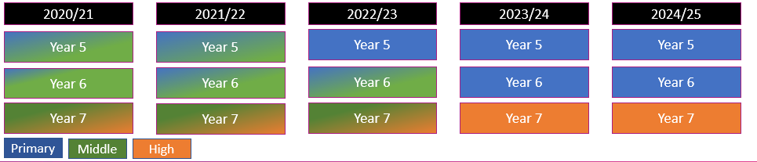

School changes
- All First schools to convert for September 2022
- Emergency variation in admission arrangements for Abbey Park Middle and St Nicholas Middle School so that there is no intake in September 2022. School closure of Abbey Park Middle and St Nicholas Middle from September 2023.
- Change of age range and removal of year 5 intake for St Barnabas for September 2023.
- Increase of PAN and change of feeder links at Pershore High for 2023 to admit all pupils in year 7 in pyramid

Impact
- This will require emergency variation to admissions changes but will mean clearer pathway for pupils in year 5 in 2022
- Rapid change for First schools – several require accommodation changes so it may be difficult to manage
- This gives families the least amount of time before changes are made.

Who is being consulted?

The consultation will be made available to:

  - Parents and carers of pupils attending / known to the school
  - Staff, Governors, Board Members of school and other local schools
  - Multi-Academy Trust
  - Local Parish, District and County Councillors
  - Immediate neighbours of individual schools
  - Local Member of Parliament
  - Cabinet Member Responsible for Children and Families
  - Cabinet Member Responsible for Education
  - Unions
  - Any other local stakeholder

How to respond to the consultation

Consultation Phase – Monday 11th October to Friday 26th November 2021

During the consultation phase anyone with an interest can express their views on the options expressed in this document and the individual school consultations.

It is very important that all those involved or have an interest have a say, we welcome your views.

All of the information available is accessible from this Worcestershire County Council Pershore Review webpage or the school website.

The seven-week consultation period commences on Monday 11th October and closes at noon on Friday 26th November 2021. It is very important that all those wishing to respond to these proposals do so within this timeframe.

We are holding consultation event(s) to allow our stakeholders to learn more about our proposals and give the opportunity to provide feedback. A summary of events can be found in on page 2 of this document.

What happens next?

How the decision will be made
At the end of the consultation period the Academy Trust will consider any issues that have been raised before deciding whether to publish or submit statutory proposals to make changes.

The Academy Trust will consider evidence from various sources in order to reach a considered view on the merits of the proposal. In particular the following factors:

- the response to the public consultation;
- the quality of education provision at the schools;
- the ability of the school to manage the proposed change to support the continued improvements at the school;
- demand for places at the school and in the local area; and
- funding to cover the capital costs of the proposed change has been secured, and that there are no issues with the school’s current budget and/or finances. In the case of expansions, academies must show they have sufficient funding for additional pupils, until lagged funding is received.

Submission of formal proposals

The proposers will take note of issues raised during the consultation. At the conclusion of the consultation period a decision will be made whether to submit a formal proposal to the decision makers, requesting their support.

Regional Schools Commissioner Decisions

For Academy schools, the Academy Trust Board will then submit a significant change request to the Regional Schools Commissioner (RSC) alongside any requests to vary school admission arrangements.

The RSC will consider a range of factors and make a balanced judgement when deciding whether to approve or reject a proposal. The RSC may also defer the approval pending further evidence. Where proposed changes are particularly controversial and could attract adverse public or press attention; the RSC may choose to escalate such proposed changes to the Secretary of State for a decision.

Related proposals

Where proposals appear to be related to other proposals, the decision-makers must consider the related proposals together. A proposal should be regarded as related if its implementation (or non-implementation) would prevent or undermine the effective implementation of another proposal.

The Local Authority will, as far as possible, seek to coordinate all proposals.

It is very important that all those involved have a say. Please submit your comments by noon on Friday 26th November 2021 by completing the online response form available on the school and WCC website. If you are unable to access the online response form you can obtain a paper copy from the school office.

Relevant documents:

Cabinet Member Decision on Change of Age Ranges & Policy: Cabinet Member Decision on Change of Age Ranges & Policy

Cabinet Report: Responding to Change of Age Range requests from Maintained Community Schools or Change of Age Range Consultations form other types of Schools Jan 2020: Cabinet Report: Responding to Change of Age Range requests

School Sufficiency and Organisation for the Pershore Area September 2021: School Sufficiency and Organisation for the Pershore Area

HeadTeacher Board record of decision Avonreach Multi-Academy Trust Change of Age ranges for The Orchard, Inkberrow, Norton-Juxta-Kempsey and Pershore High Dec 2018 [ARCHIVED CONTENT] (nationalarchives.gov.uk)

