St Barnabas CE First Middle School

Remote Learning - Reception
Wednesday 24th June PM & Thursday 25th June PM

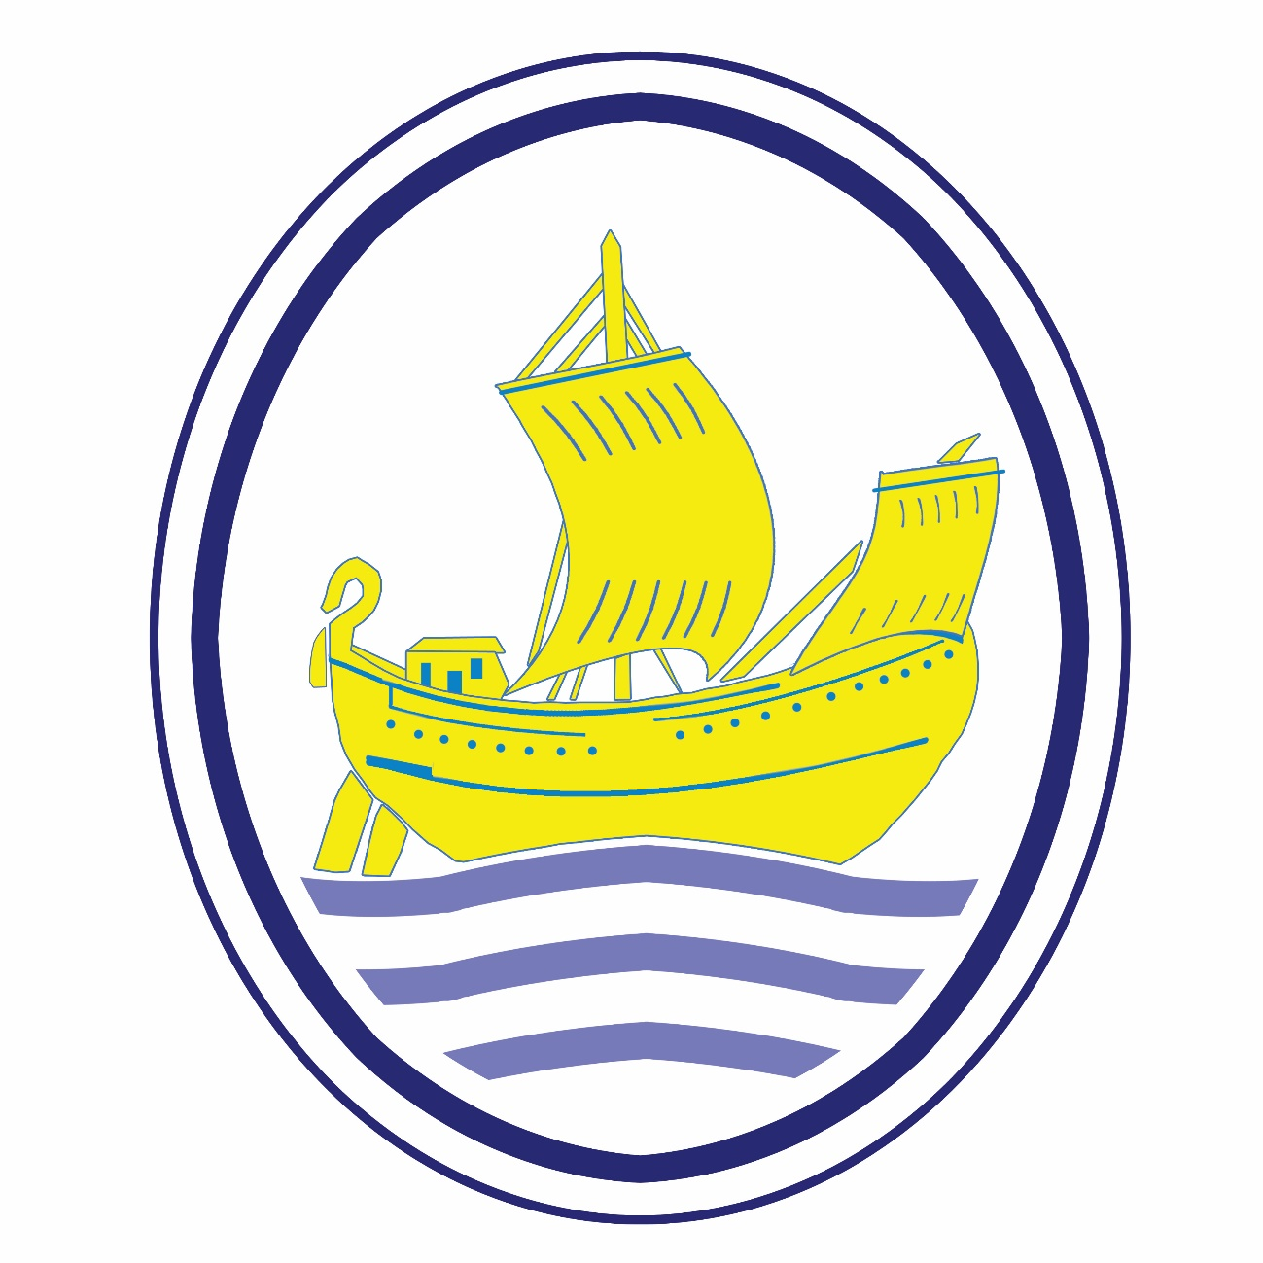

Name: ______________________________________

Class: _______________________________________

The Very Hot Day
Learning focus: Speaking and vocabulary
Show a sunny picture or look outside.
Ask:
- What can you see?
- How does the weather feel?
- What would you wear?
- What might melt in the sun?
Challenge children to use describing words:
- hot
- bright
- sunny
- warm
- shiny
Extension: Adult writes down the child's sentence:
"The sun is bright."

Draw and Label a Summer Picture
Learning focus: Mark making and early writing
Children draw:
sun
ice cream
hat
sunglasses
water bottle
Label each picture using initial sounds or simple words.
Example:
sun
hat
ice

4. Weather Reporter
Inspired by the booklet's weather journalist task.
Learning focus: Speaking and listening
Give children a toy or pretent microphone.
Prompt:
"Hello everyone! Today's weather is..."
They can say:
- sunny
- cloudy
- windy
- rainy
Extension: Record their weather report.

Summer Rhyming Game
Learning focus: Phonological awareness
Can children think of rhymes for:
- sun
- hot
- hat
Examples:
- sun / fun
- hat / cat

What's Melting?
Learning focus: Vocabulary and prediction
Show pictures of:
- ice cream
- chocolate
- ice cube
- teddy bear
Ask:
- Which will melt?
- Why?
Children explain:
"The ice cream will melt because it is hot."

Sunshine Shadow Measuring
Learning objectives:
- Compare lengths (longer/shorter)
- Use mathematical language
- Estimate and measure
You will need:
- Chalk (outside) or paper and pencil
- Toys or household objects
Activity
- Place 3–5 objects in the sunshine (e.g. teddy, water bottle, toy car).
- Look at the shadows they make.
- Ask:
  - Which shadow is the longest?
  - Which shadow is the shortest?
  - Can you put them in order from shortest to longest?
- Measure each shadow using non-standard units:
  - How many footsteps long?
  - How many building blocks long?
  - How many hand spans long?

Record Your Findings
Object | Length of Shadow
Teddy | 4 footsteps
Bottle | 2 footsteps
Car | 3 footsteps
Questions
- Which shadow was the longest?
- Which was the shortest?
- How many footsteps longer was the teddy's shadow than the bottle's?
Challenge
Draw the shadows and write the numbers beside them.

Extension: Repeat later in the day and see if the shadows have changed. Which shadows got longer? Which got shorter?

Cool-Down Poster
Learning focus: Communication and simple writing
Children draw ways to stay cool:
- drink water
- sit in shade
- wear a hat
Adult scribes their ideas. Add captions:
Drink water.
Wear a hat.
A short forecast

Congratulations you have completed your remote learning. Take your booklet back to school for 5 HPs.

