Key Priority 3: Challenge – Let’s Go Zero
Context: Carbon report completed for DOWMAT March 2025, Climate Change action plan reviewed March 2025.
Carbon / Site Walk / Sustainability Mapping / Travel Survey / Water Usage
PROBLEM - WHY? | INTERVENTION  EVIDENCED INFORMED PROCESS  DESCRIPTION – WHAT?  (Active Ingredients) | IMPLEMENTATION ACTIVITIES – HOW? COST? | IMPLEMENTATION OUTCOMES – (who, when how) | FINAL OUTCOMES | RAG
Limited curriculum content for environmental change & sustainability including Careers | Core Component 1  Staff are clear what teaching for sustainable futures is and where in the curriculum it can be taught.  Core Component 2  Subject leads have identified key subjects and areas where sustainability is taught in the curriculum which clear progressive steps.  Core Component 3  Opportunities for children to recognise the opportunities for careers in sustainability  Core Component 4  To act as role models for children regarding energy saving, food waste, travel habits, use of recycled materials.  Core Component 5  Building systems in place to reduce carbon footprint. | Training  - Teaching for sustainable futures /Embedding sustainability into the curriculum  - National College training  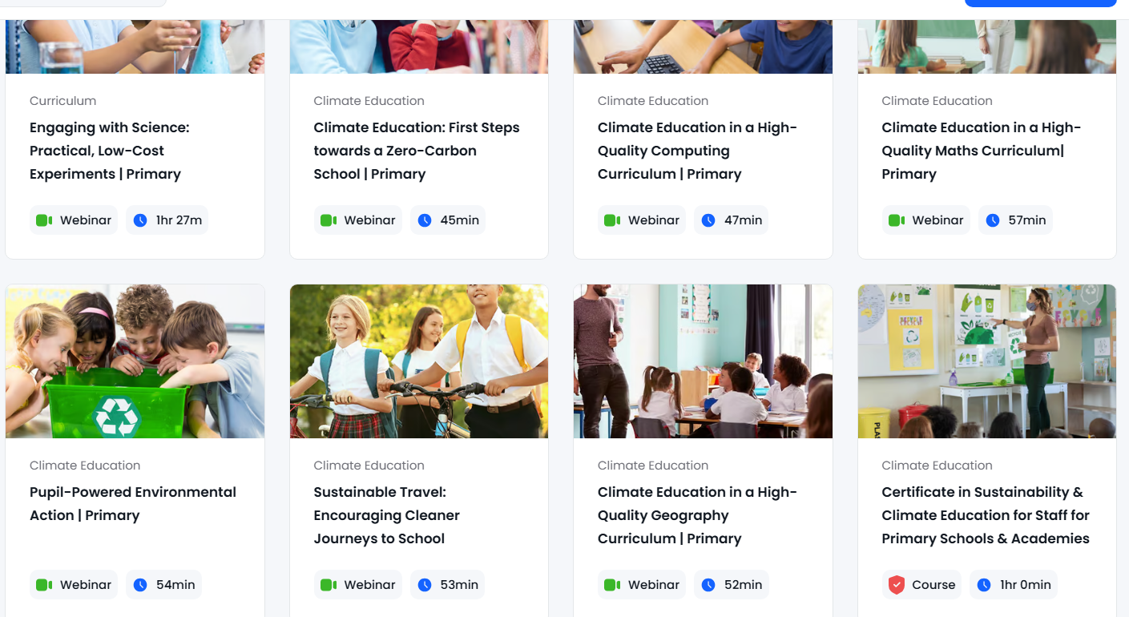  Educational materials  Canteen to Classroom Canteen to Classroom - ProVeg UK  Taste it don’t waste it - Taste It, Don't Waste It: Education resources on the topic of food waste | WRAP - The Waste and Resources Action Programme  Resources  Separate food waste collection fortnightly  Light monitors  Earthkeepers group  Walk to School Week May 2026  Earth Day 22/4/26  Displays around school / letters to parents  WWF Switch off Fortnight November 2025  Careers Day Jan 2025  Bikeability 2025-6  Enrichment Week 2025-6  Caring for God’s World – Church School Partnership  Worships  - Proveg  - Big Garden watch – RSPB  - Severn Trent  - Recycling  - Water Aid  Young Climate Warriors  Coaching & Mentoring  Focus group to lead initiative – regular update meetings.  Monitoring  - DH – learning walks / drop ins  - Governor Enquiry walks termly  - Pupil Voice  - Eco group to visit Govs / SLT. | Immediate/Short Term (Autumn 1)  Fidelity-  - Curriculum plans reviewed.  - Food waste collection fortnightly.  Reach-  100% staff have completed sustainability curriculum CPD  All children aware of climate change and sustainability plans  Medium Term  Fidelity  - New curriculum plans in place  - Focus group meet half termly.  - Awareness activities completed. | Short term (Autumn)  100% of staff are clear about teaching for sustainable futures.  Medium term (Annual – by July 2026)  Reach  Eco schools award achieved.  100% of Y5 & 7 have had the opportunity to undertake Bikeability.  Reduction in Carbon footprint based on baseline March 2025.  100% of children know about different careers involved in climate change and sustainability.  A range of awareness events are completed and children can talk with enthusiasm and confidence about changes that need to be made / have been made.  Long term  St Barnabas school is working towards a sustainable school; energy, waste, water.  100% of children are aware of their role in a sustainable future.

Actions and Impact to Date

Autumn 1 | - Earthkeepers (Eco Club) established – September 30th 2025  - Geography/ History Lead researched sustainability offer of Kapow teaching scheme, including the study of urban farming in KS3  - Earthkeepers annual plan created and shared with Leads: LB and CW- October 1^{st 2025}  - Bike Day weekend event – organised by FOSB – October 11th 2025  - Cycle to School Week – daily bike bus – October 13th – 17th  - Earthkeepers autumn 1 meeting to discuss first mission: electricity – designing ‘Switch me off’ mini posters to go around all light switches. October 14th 2025  - GreenApe Pedal Powered Smoothie Bike Hire Service – October 17th 2025  - Worcester Bike assembly – October 17th 2025  - House Captains launched art competition (in support of Earthkeepers) with recycled art element – October 20th  - Geography/ History Lead shared sustainability careers in Science – October 22nd
Autumn 2 | - Health and Safety audit – LAB – questions posed and discussions had about how H&S linked with Let’s Go Zero campaign  - Let’s Go Zero – staff meeting – November 5th 2025  - “Switch Off fortnight” – information sent to parents; Earthkeepers leading audit and patrols - turning off lights when rooms are empty; unplugging appliances when not in use; making use of natural light where possible by raising blinds; electricity patrols and extra reminder posters near switches around school.
Spring 1 | - Enrichment Week: Future Pathways – January 26th – 30th 2026. Year 5, 6 and 7 STEM workshop - impact has shown improved engagement, boosting problem-solving, critical thinking, and collaboration skills through hands-on learning  - Earthkeepers visiting EnviroSort at Severn Waste Services. Impact: Earthkeepers greater informed about sustainability and recycling; all children led worship to share their findings with whole school - January 29th 2026  - Severn Trent worship. Impact: pupils more informed about sustainability in water company  - Earthkeepers completed tap audit and planning water saving posters – Jan/ Feb 2026. Impact: greater understanding of resource use and waste, alongside improved pupil ability to identify practical, everyday actions to reduce water consumption.  - Earthkeepers planning biodiversity/ nature focus for Spring 2 – bird boxes, wildflower seeds. Impact: a deeper understanding of local ecosystems and the importance of habitat creation.
Spring 2 | - Earthkeepers to share water saving posters with whole-school to raise awareness of and impact of water consumption  - March 18th Caring for God’s World – special worship with RE lead to look at our actions in God’s world and our moral responsibility to protect the Earth. Impact: Children have greater understanding of links between the story of creation and current human impact  - Biodiversity/ nature focus to raise awareness of protecting wildlife – Earthkeepers installing bird boxes on Caring for God’s World to symbolise caring for the environment. Impact: The project increased awareness of biodiversity and conservation, while fostering a sense of responsibility and stewardship for the natural environment. It also supported pupil leadership and engagement, contributing to a more sustainable and nature-conscious school environment.  - March 20th - Switch off hour, supporting reflections on how much we rely on technology and to show that learning can happen in many different ways. Impact: meaningful opportunity to reflect on their reliance on technology and explore alternative approaches to learning. The initiative successfully increased awareness of digital dependency, with pupils demonstrating a greater understanding of how technology supports, but can also limit, aspects of learning and wellbeing.
Summer 1 | - April 22nd - Earth Day – church school partnership event, strengthening links to recent space exploring and embedding key messages about the impact of small acts. Impact: children have increased awareness of their role in a sustainable future; children able to articulate ways in which to support the planet.  - David Attenborough’s 100th birthday – 100 Acts of Green. Impact: measurable increase in pupils’ awareness, understanding, and active commitment to environmental sustainability across the school community. By linking learning to a real-world figure associated with environmental advocacy, pupils demonstrated heightened engagement and motivation to participate in sustainable practices. Impact: children have increased awareness of their role in a sustainable future; children able to articulate ways that David Attenborough has devoted his life and career to caring for the planet.
Summer 2 | Sustainability across the curriculum – document to be reviewed by SLT and subject leaders to ensure sustainability is woven into the whole curriculum. Impact: strengthened the strategic integration of environmental education across all subject areas. This has ensured greater consistency, progression, and intentionality in how sustainability is embedded within teaching and learning. As a result, pupils are developing a more coherent understanding of environmental responsibility and global citizenship across the curriculum, supporting the school’s commitment to long-term sustainable practice and values-led education

